Title or Task: |   

Description:

Files Required
Suitable for Classes: | AIT • Multimedia • Cert II IT • Cert II Bus
Area: | Technology & Enterprise
Teacher: | Mr Peter Faulks

Timeline

Date Due:
Task Brief: | In class lesson

Outcomes:

Items highlighted in yellow are tasks for you to complete
Items in Blue italics are help tips
SOLUTIONS

1. Creation of database and data entry, using the data provided

- lose 1 mark per error or omission 5 marks

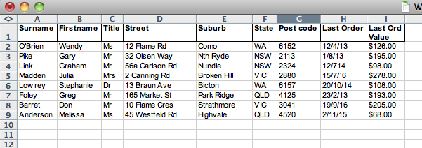

2. Creation and printing of newsletter (NSW and QLD only - four letters)

- lose 1 mark per error or omission
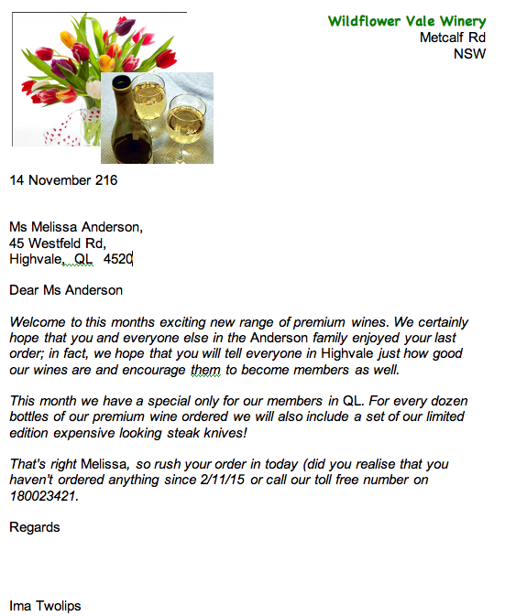
8 marks

3. Spreadsheet data entered correctly as per question sheet
- lose 1 mark per error or omission 2 marks

Formula for profit entered correctly in all cells
- lose 1 mark per error or omission 2 marks

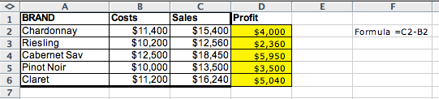
Creation of pie graph showing percentages
- lose 1 mark per error or omission 5 marks

Word-processing document created correctly 1 mark

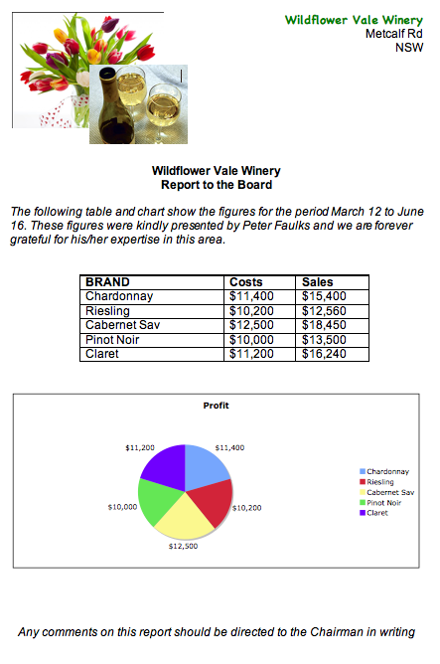
Graph and spreadsheet placed correctly into WP document

- lose 1 mark per error or omission 2 marks

2 + 2 + 5 + 1 + 2 = 12 marks

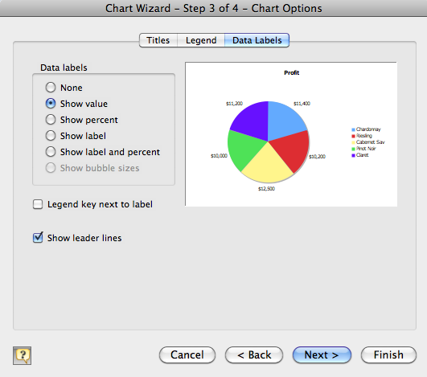

5 + 8 + 12 = Total: 25 marks

Integrate Peronal Productivity

(The following exercise will require use of a word processor, spreadsheet and database packages.)

The Wildflower Vale Winery sells wine to members of its wine club. Every three months a brochure and accompanying letter are sent out to members giving them details of wine for sale and information on any ‘specials.' Members then complete the order form return it to the winery and orders are processed and dispatched.

1.
Use the following data and a database package to create a database for part of the Wildflower Vale Winery’s customer database.

Surname | Firstname | Title | Street | Suburb | State | Post code | Last Order | Last Ord Value
O’Brien | Wendy | Ms | 12 Flame Rd | Como | WA | 6152 | 12/4/03 | $126.00
Pike | Gary | Mr | 32 Olsen Way | Nth Ryde | NSW | 2113 | 1/8/03 | $195.00
Link | Graham | Mr | 56a Carlson Rd | Nundle | NSW | 2324 | 12/7/03 | $98.00
Madden | Julia | Mrs | 2 Canning Rd | Broken Hill | VIC | 2880 | 15/7/03 | $278.00
Lowrey | Stephanie | Dr | 13 Braun Ave | Bicton | WA | 6157 | 20/10/03 | $108.00
Foley | Greg | Mr | 165 Market St | Park Ridge | QLD | 4125 | 23/2/03 | $193.00
Barret | Don | Mr | 10 Flame Cres | Strathmore | VIC | 3041 | 19/9/03 | $205.00
Anderson | Melissa | Ms | 45 Westfeld Rd | Highvale | QLD | 4520 | 2/11/03 | $68.00
5 Marks

2.
Use your word processor to create and print the following mail merge letter, only to those customers in NSW or Queensland.

Wildflower Vale Winery
Metcalf Rd
NSW
Todays date

<Title> <Firstname> <Surname>
<Street>
<Suburb> <Postcode>

Dear <Title> <Surname>,

Welcome to this months exciting new range of premium wines. We certainly hope that you and everyone else in the <Surname> family enjoyed your last order; in fact, we hope that you will tell everyone in <Suburb> just how good our wines are and encourage them to become members as well.

This month we have a special only for our members in <State>. For every dozen bottles of our premium wine ordered we will also include a set of our limited edition expensive looking steak knives!

That’s right <Firstname>, so rush your order in today (did you realise that you haven’t ordered anything since <Last Order> ?) or call our toll free number on 180023421.

Regards
SDealer
Sly Dealer (replace with your own name)
8 Marks

3.
Wildflower Vale also needs to present a report to its board showing profits over recent times on some its leading brands. Use a spreadsheet package to enter the following data and create a formula that will calculate the profit on each brand (Sales - Costs).

Create a pie graph from this information that will show the percentage profits of each brand. Place the spreadsheet data and the graph into a word-processing document that will be presented to the board. These should be preceded by the following:

Wildflower Vale Winery
Report to the Board

The following table and chart show the figures for the period March 12 to June 16. These figures were kindly presented by [add your name here] and we are forever grateful for his/her expertise in this area.

Any comments on this report should be directed to the Chairman in writing.

Spreadsheet Data
BRAND | Costs | Sales
Chardonnay | $11,400 | $15,400
Riesling | $10,200 | $12,560
Cabernet Sav | $12,500 | $18,450
Pinot Noir | $10,000 | $13,500
Claret | $11,200 | $16,240

12 marks

5 + 8 + 12 = Total: 25 marks



